**Event Report of Club/Committee VIT Debate Club EV001**

|  |  |
| --- | --- |
| **Name of the Club** | VIT Debate Club |
| **Name of the Event** | Debate Session on One Nation One Election |
| **Student Vertical** | Engineering |
| **Instalment** | 1 |
| **Date and Time of the Event** | 21st February 2026, 4:00 PM |
| **Mode of the Event** | Offline |
| **Venue** | VIT Biwewadi, Room No. 1002 |
| **No. of Participants** | 80 |
| **Duration of Event** | 2 hours |
| **Name of Guests** | None |
| **Designation of Guests** | None |
| **Nature of Guest** | None |
| **Event Category** | Academic |
| **Event organized in collaboration with** | None |
| **Resource person details if any** | None |
| **Achievements & Highlights** | Active participation from 80 students, informative discussion on the topic |

|  |  |  |  |
| --- | --- | --- | --- |
| **S.No.** | **Program Outcome** | **Rating (0-3)** | **Remarks** |
| 1 | Engineering knowledge: Apply the knowledge of mathematics, science, engineering fundamentals, and an engineering specialization to the solution of complex engineering problems | 2 | Good understanding of the topic |
| 2 | Problem analysis: Identify, formulate, review research literature, and analyze complex engineering problems reaching substantiated conclusions using first principles of mathematics, natural sciences, and engineering sciences | 2 | Students showed ability to analyze the topic |
| 3 | Design/development of solutions: Design solutions for complex engineering problems and design system components or processes that meet the specified needs with appropriate consideration for the public health and safety, and the cultural, societal, and environmental considerations | 1 | Limited design solutions discussed |
| 4 | Investigation of complex problems: Investigate, analyze, and solve complex problems using research-based knowledge and research methods including design of experiments, analysis and interpretation of data, and synthesis of the information to provide valid conclusions | 2 | Students showed ability to investigate the topic |
| 5 | Modern tool usage: Create, select, and apply appropriate techniques, resources, and modern engineering and IT tools, including prediction and modeling to complex engineering activities with an understanding of the limitations | 1 | Limited use of modern tools |
| 6 | The engineer and society: Apply reasoning informed by the contextual knowledge to assess societal, health, safety, legal, and cultural issues and the consequent responsibilities relevant to the professional engineering practice | 2 | Good understanding of social implications |
| 7 | Environment and sustainability: Understand the impact of the professional engineering solutions in societal and environmental contexts, and demonstrate the knowledge of, and need for sustainable development | 2 | Students showed awareness of sustainability |
| 8 | Ethics: Apply ethical principles and commit to professional ethics and responsibilities and norms of the engineering profession | 2 | Students showed understanding of ethical principles |
| 9 | Individual and team work: Function effectively as an individual, and as a member or leader in diverse teams, and in multidisciplinary settings | 2 | Good team work and participation |
| 10 | Communication: Communicate effectively on complex engineering activities with the engineering community and with society at large, such as, being able to comprehend and write effective reports and design documentation, make effective presentations, and give and receive clear instructions | 2 | Effective communication among participants |
| 11 | Project management and finance: Demonstrate knowledge and understanding of the engineering and management principles and apply these to one’s own work, as a member and leader in a team, to manage projects and in multidisciplinary environments | 1 | Limited discussion on project management |

## GEO-Tagged Photograph Section

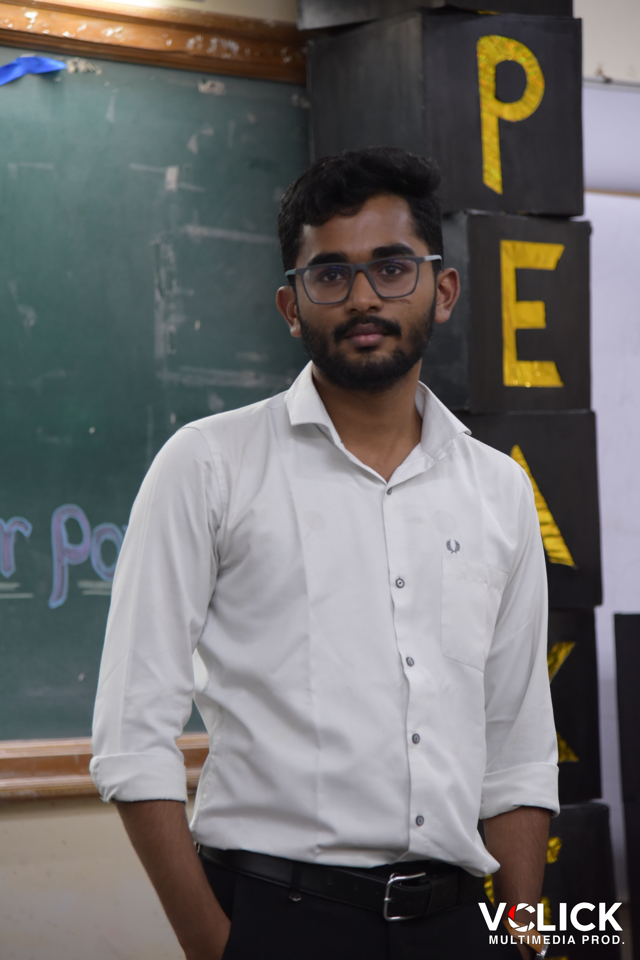

Image: Speakers_edge_-79.jpg

* Photo 1: Group photo of participants in front of VIT Biwewadi building
* Photo 2: Speaker presenting the topic
* Photo 3: Audience participating in the discussion

## Non GEO-Tagged Photograph Section

* Photo 1: Debate session in progress
* Photo 2: Participants engaging in discussion
* Photo 3: Event organizers and volunteers

|  |  |
| --- | --- |
| **Field Name** | Value |
| **Overall Experience** | Good |
| **Suggestions for Improvement** | More time for discussion, provide snacks and refreshments |

|  |  |
| --- | --- |
| **Field Name** | Value |
| **Total Budget** | 5000 |
| **Actual Expenses** | 4000 |
| **Expenses Breakdown** | Venue rental: 1000, Sound system: 800, Miscellaneous: 2200 |

________________________________________________________________________________

Generated by CampusOps Event Report Generator  
Date: February 27, 2026 at 12:15 AM